What is Selenium Grid?

Selenium Grid is a smart proxy server that makes it easy to run tests in parallel on multiple machines (different remote machine)

Selenium Grid Architecture

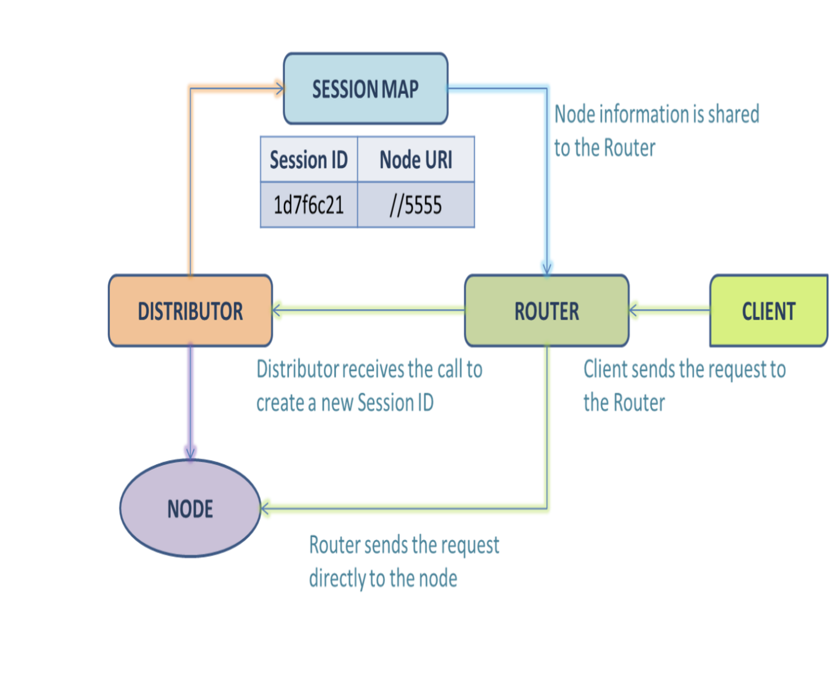

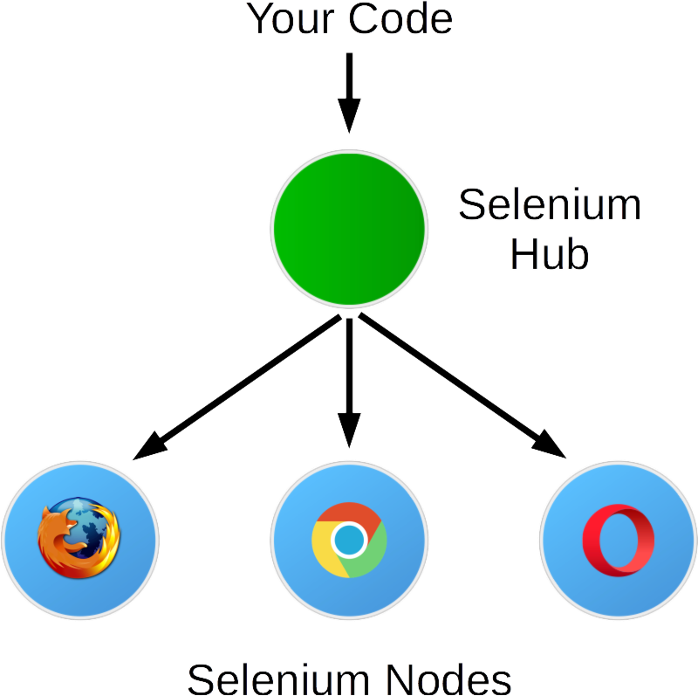

------------

Download the jars and drive required for Selenium Grid running and keep in same path

Download the Selenium grid jar from their official site

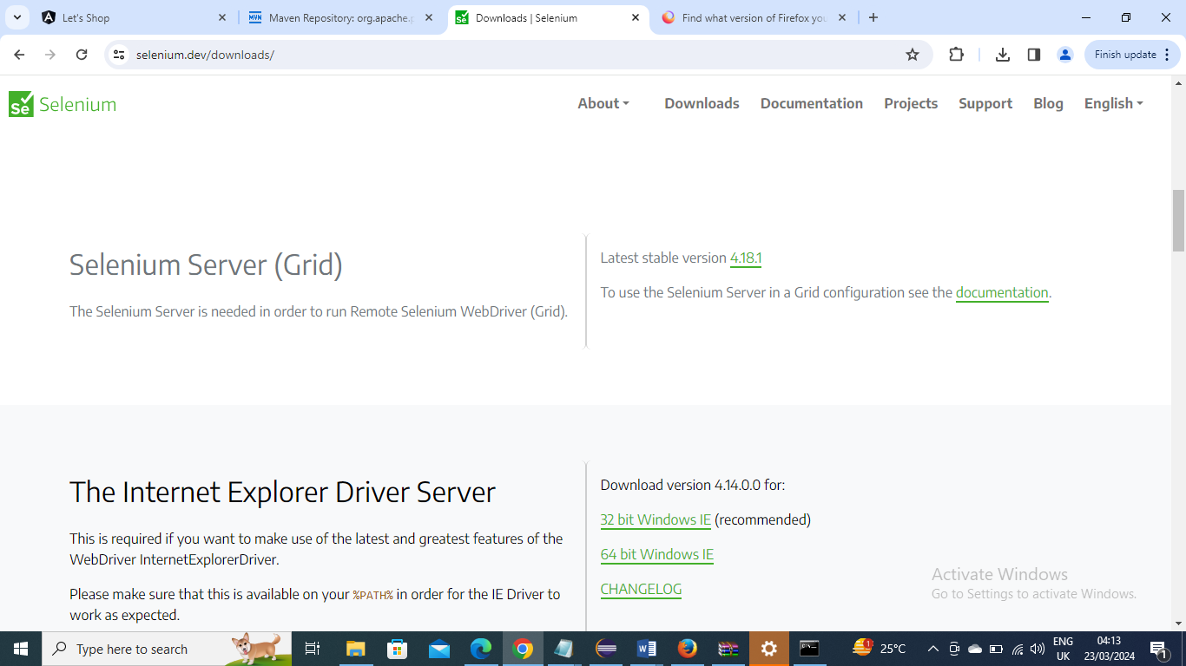

Next download chrome and Gecko(Mozilla) driver and keep in same path

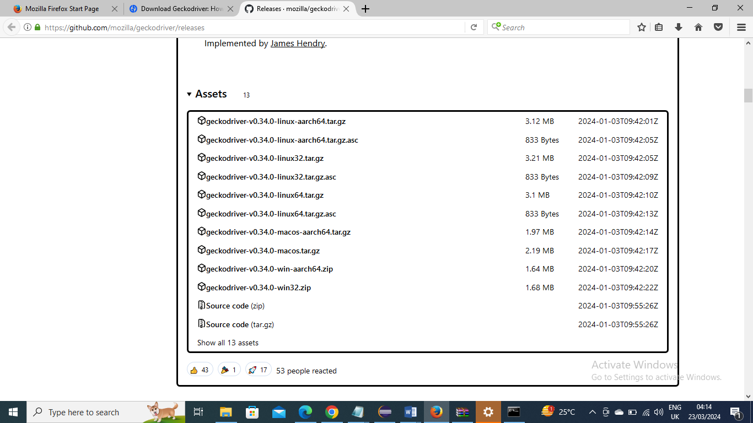

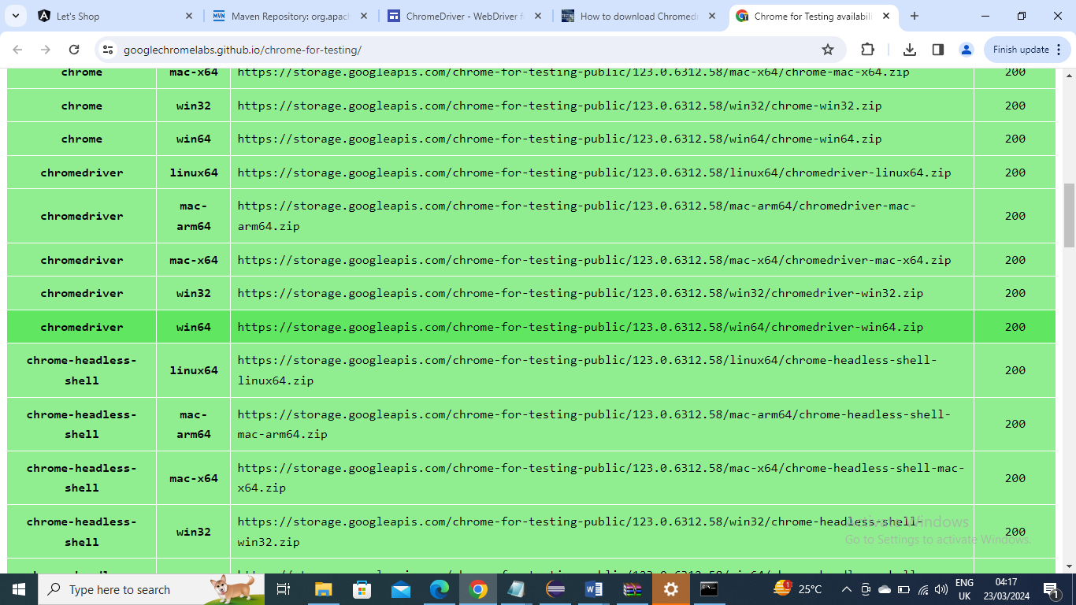

Now keep all three in same folder

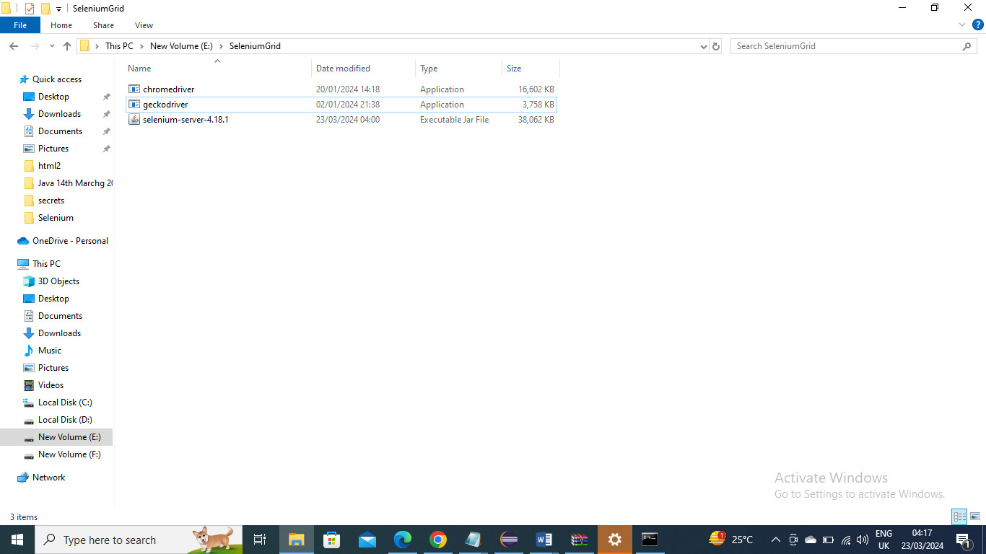

------------

Go to that particular folder in command prompt

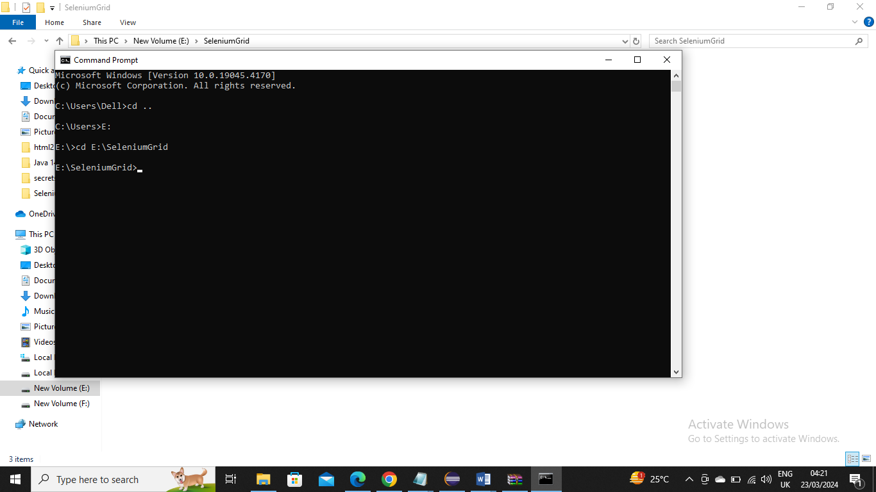

Below is command we are asking Selenium Grid to start Hub and its components

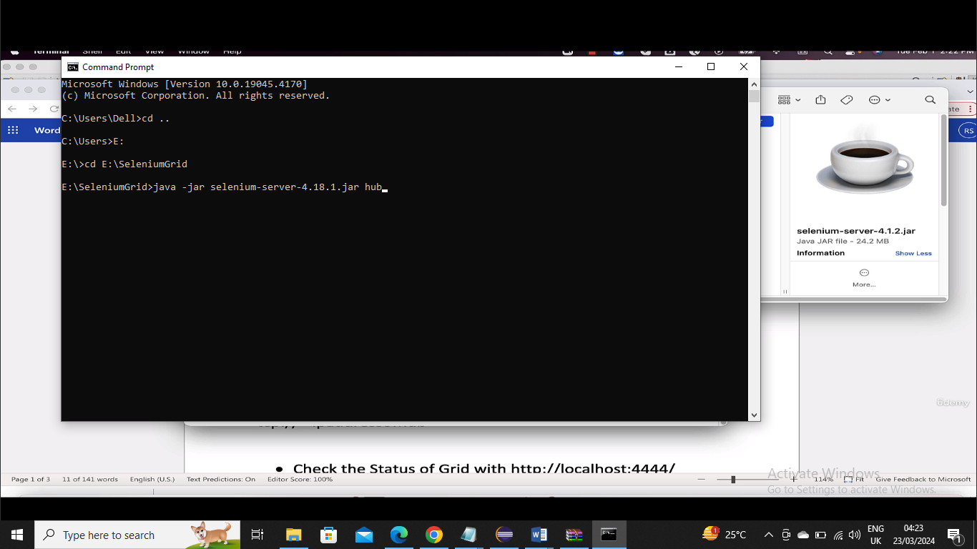

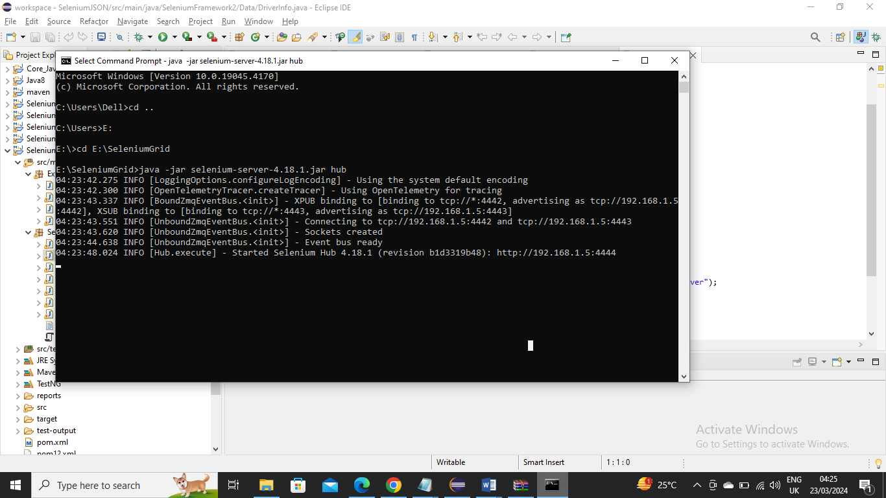

Now you can check giving in url localhost:4444 to see it started

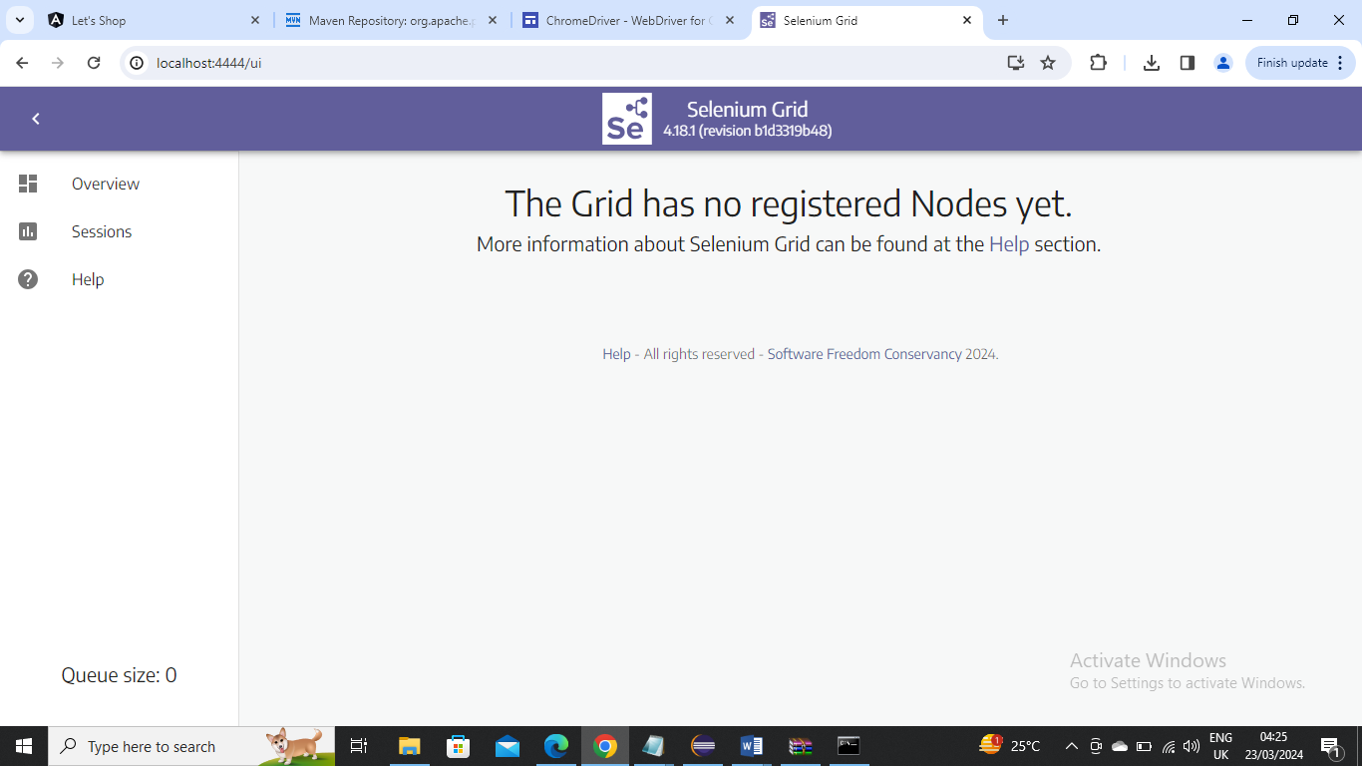

----------------

Now we need to add Nodes (drivers) to this

Now open new command prompt since old one will be running and you cannot enter anything and give below

Go to the drivers directory and give below command

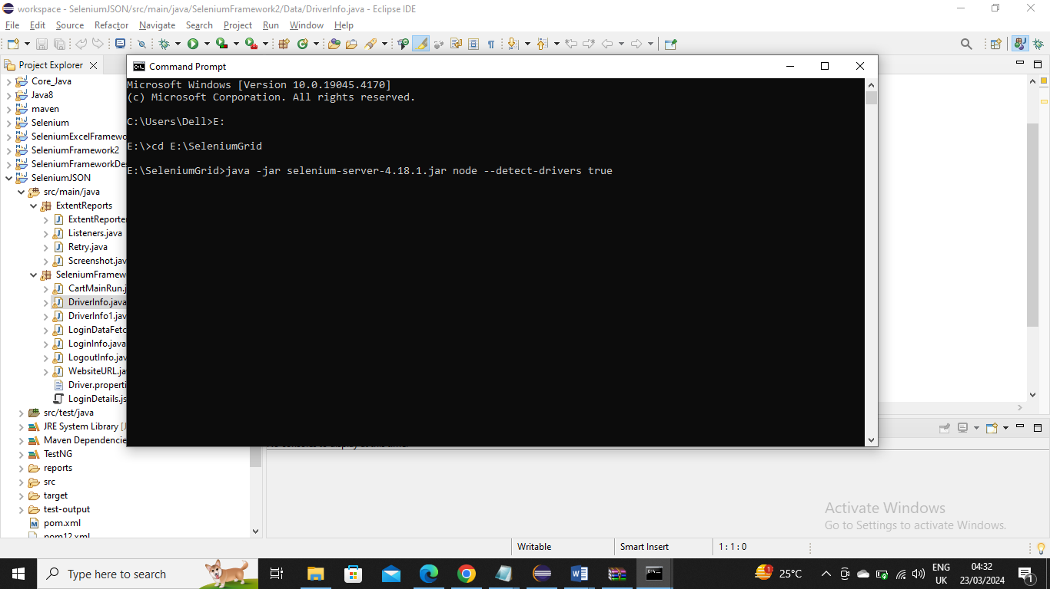

Now you can see in localhost:4444 the nodes are added

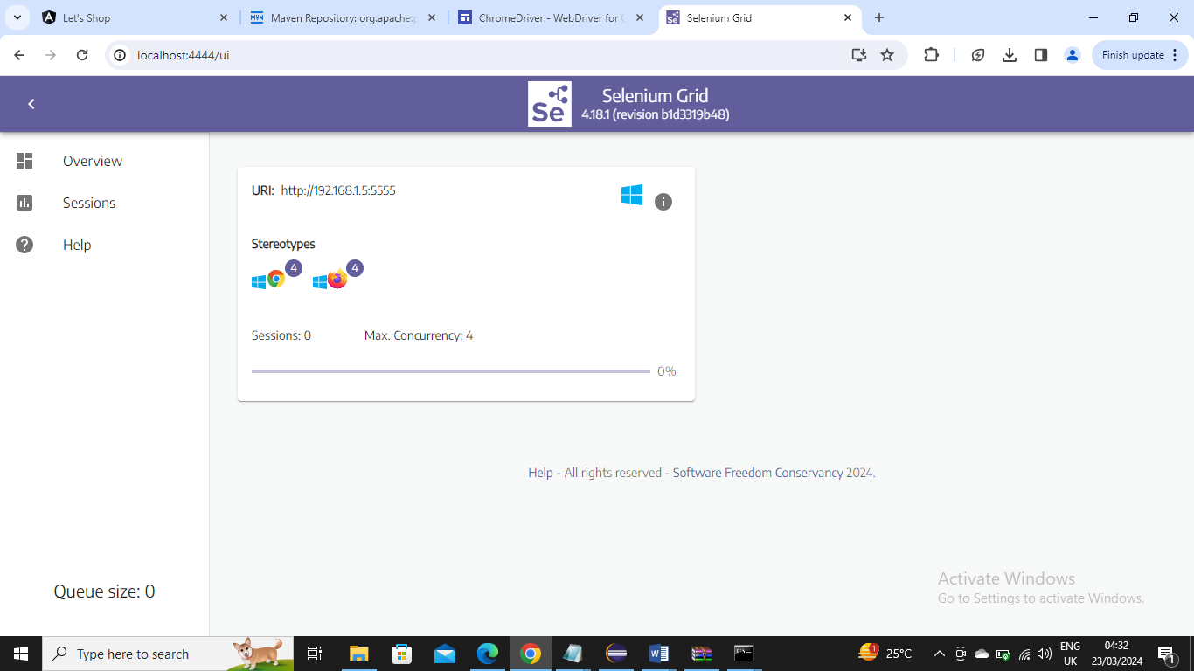

-----------------------

Now you need to repeat same download jar and download drivers and run the commands in remote machine. Since I don’t have remote machine I took screenshot from tutorial just for an understanding

Below is the command you need to enter in remote machine comand prompt

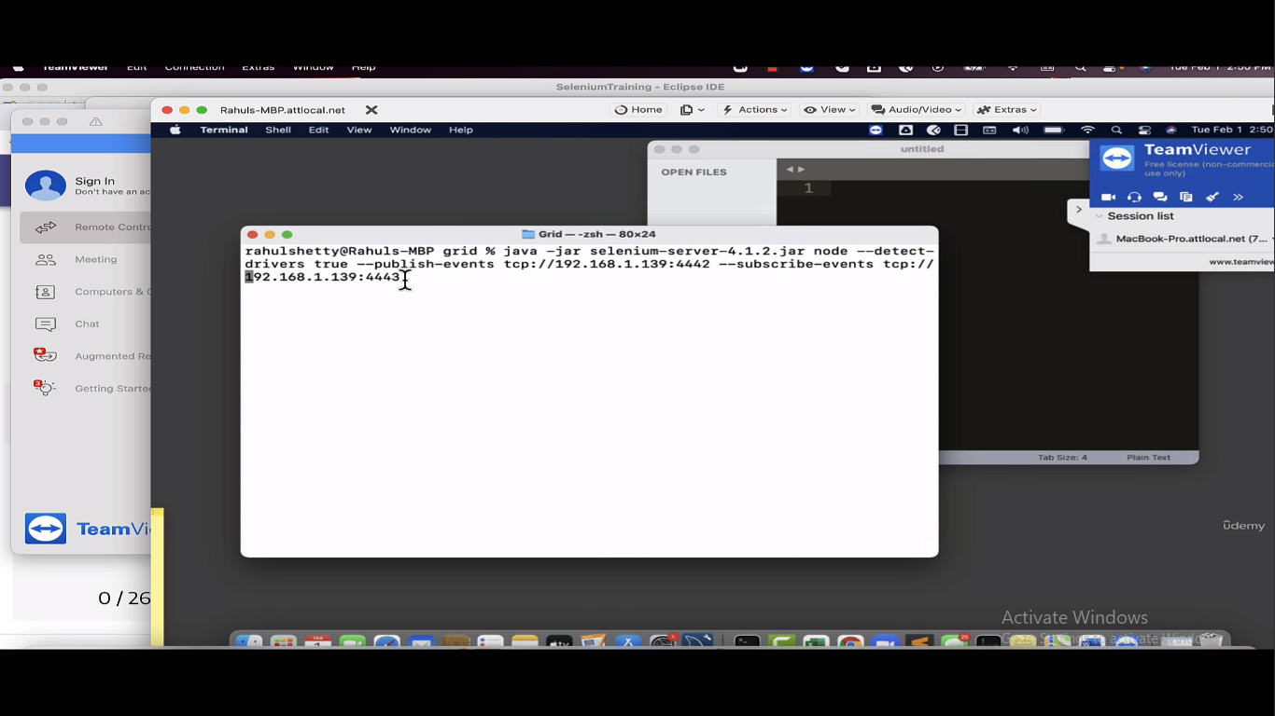

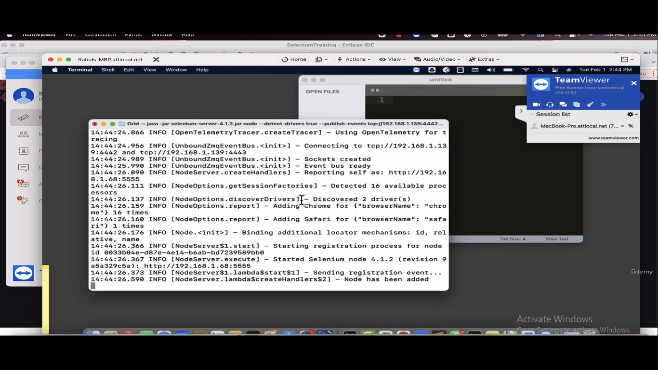

The reason you enter because you are saying to point to local machine XPUB (publishing event) 4442 and XSUB (subscribe event) 4443



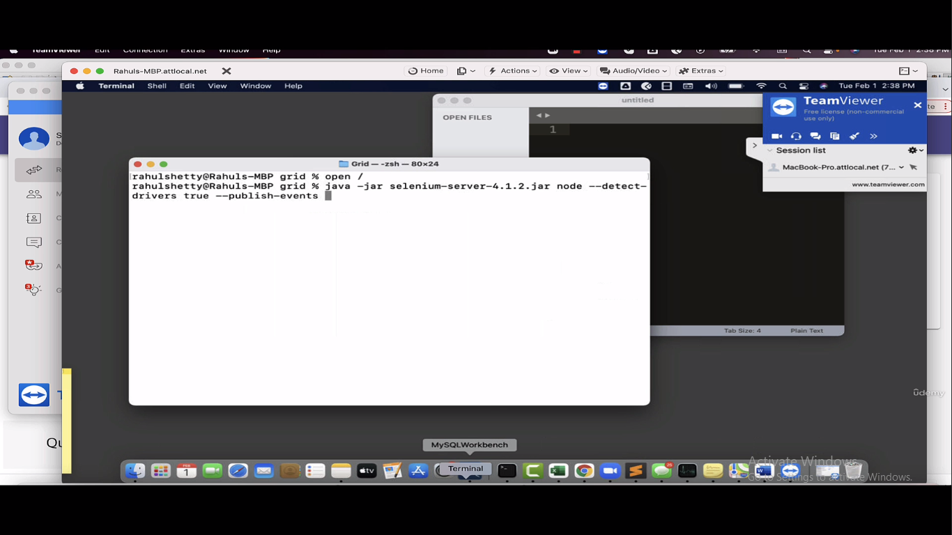

Now if you see in local machine localhost:4444 you will see two node one from local system and other node from different physical system

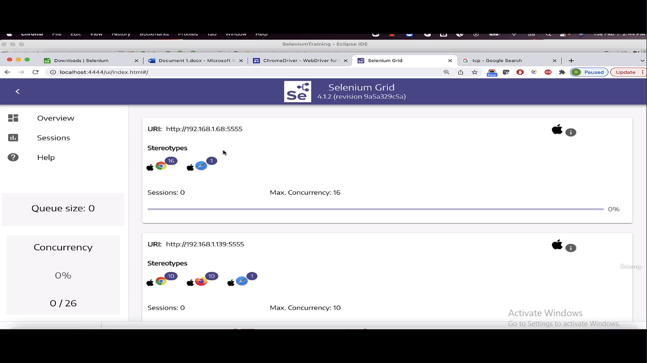

------------------

Now let’s write our simple couple of code in local machine

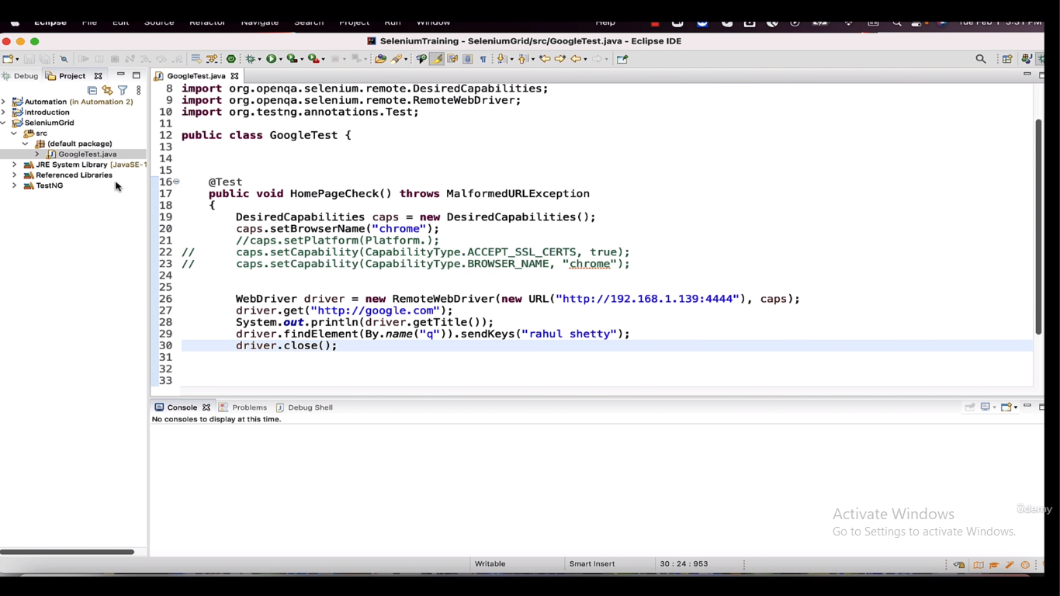

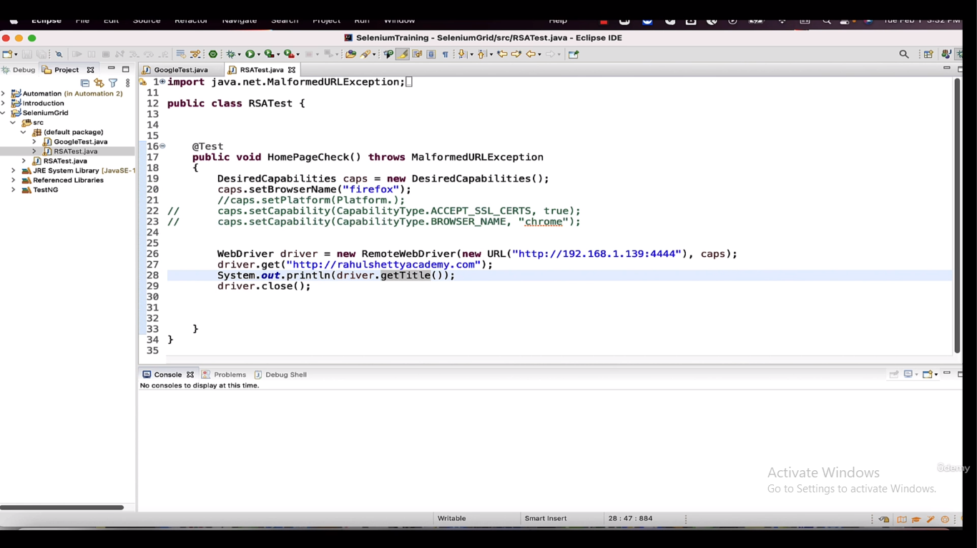

Now make your TestNG XML as required to run both the classes on parallel

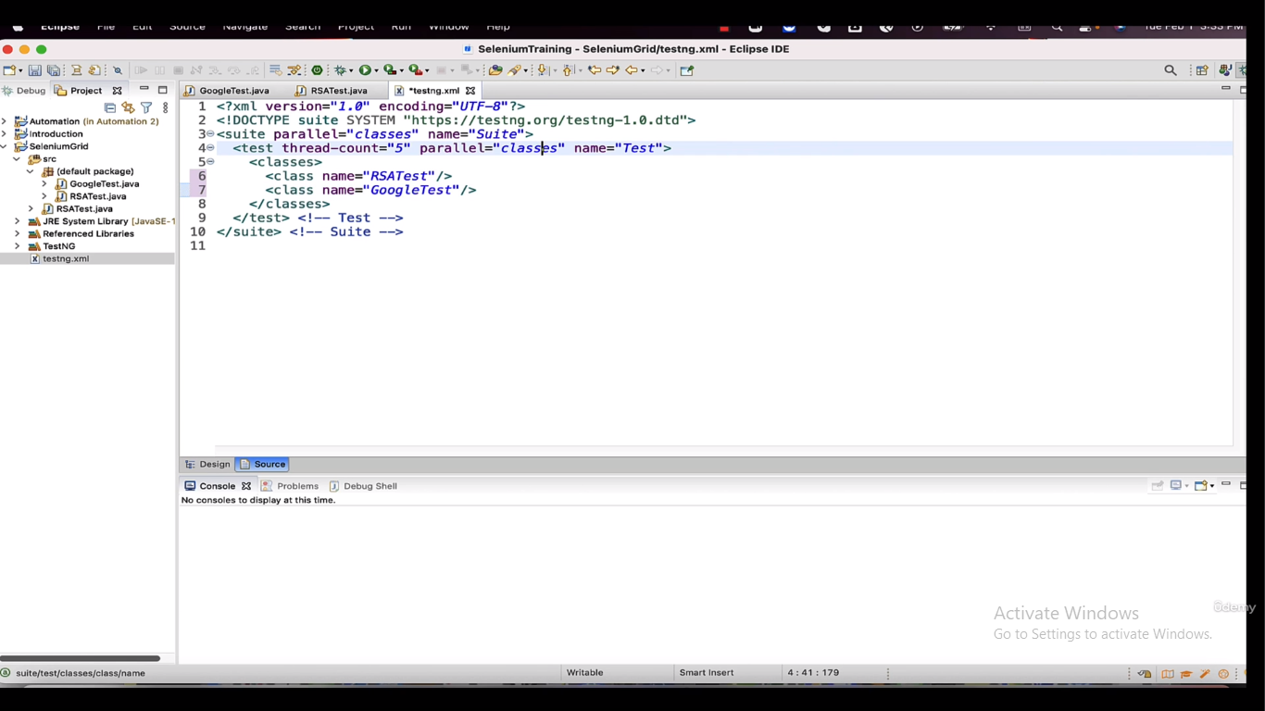

Now run the test

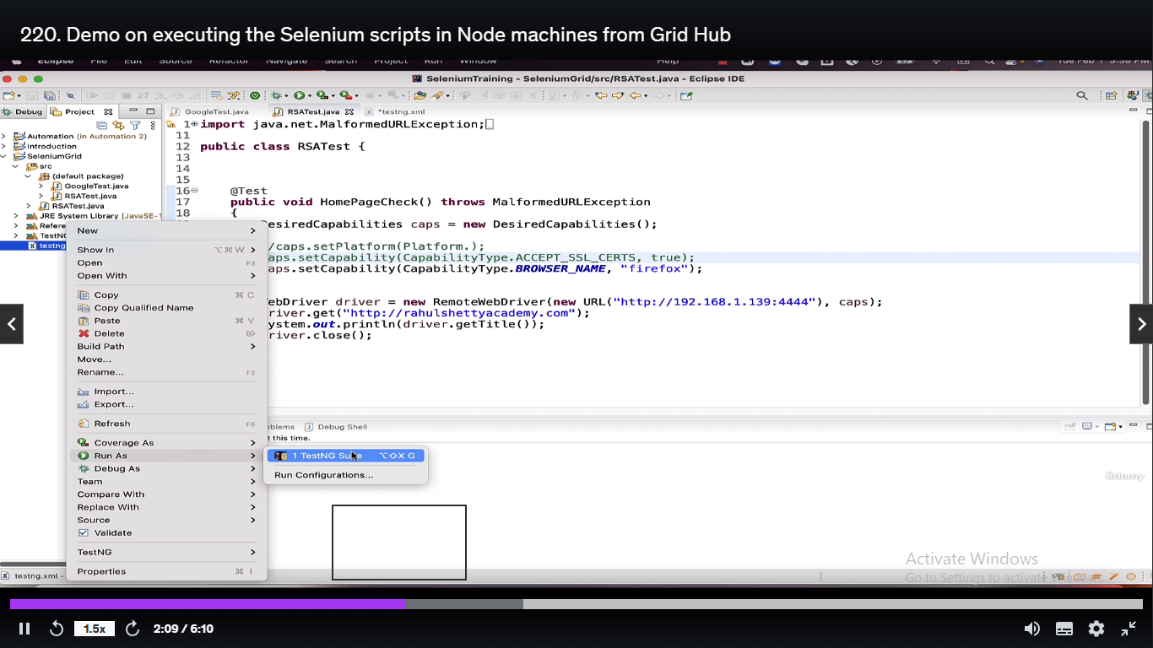

Basically the expectation would be since Node1 doesn’t have firefox, the distributor should send GoogleTest program should go to Node1 and RSATest program to Node2



Below is the output where it ran successfully

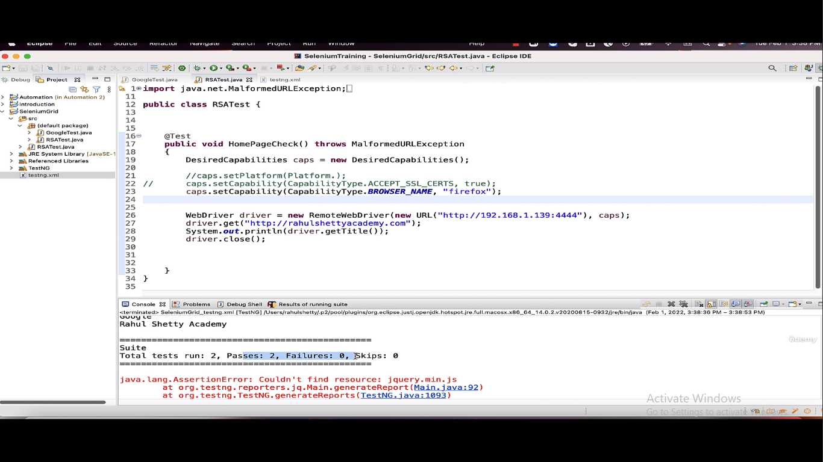

You can see below Node2 running RSATEST (firefox) program i.e. in remote machine and you can see below node1 running GoogleTest (chrome) program at back side (you can see right side that is from local machine)

